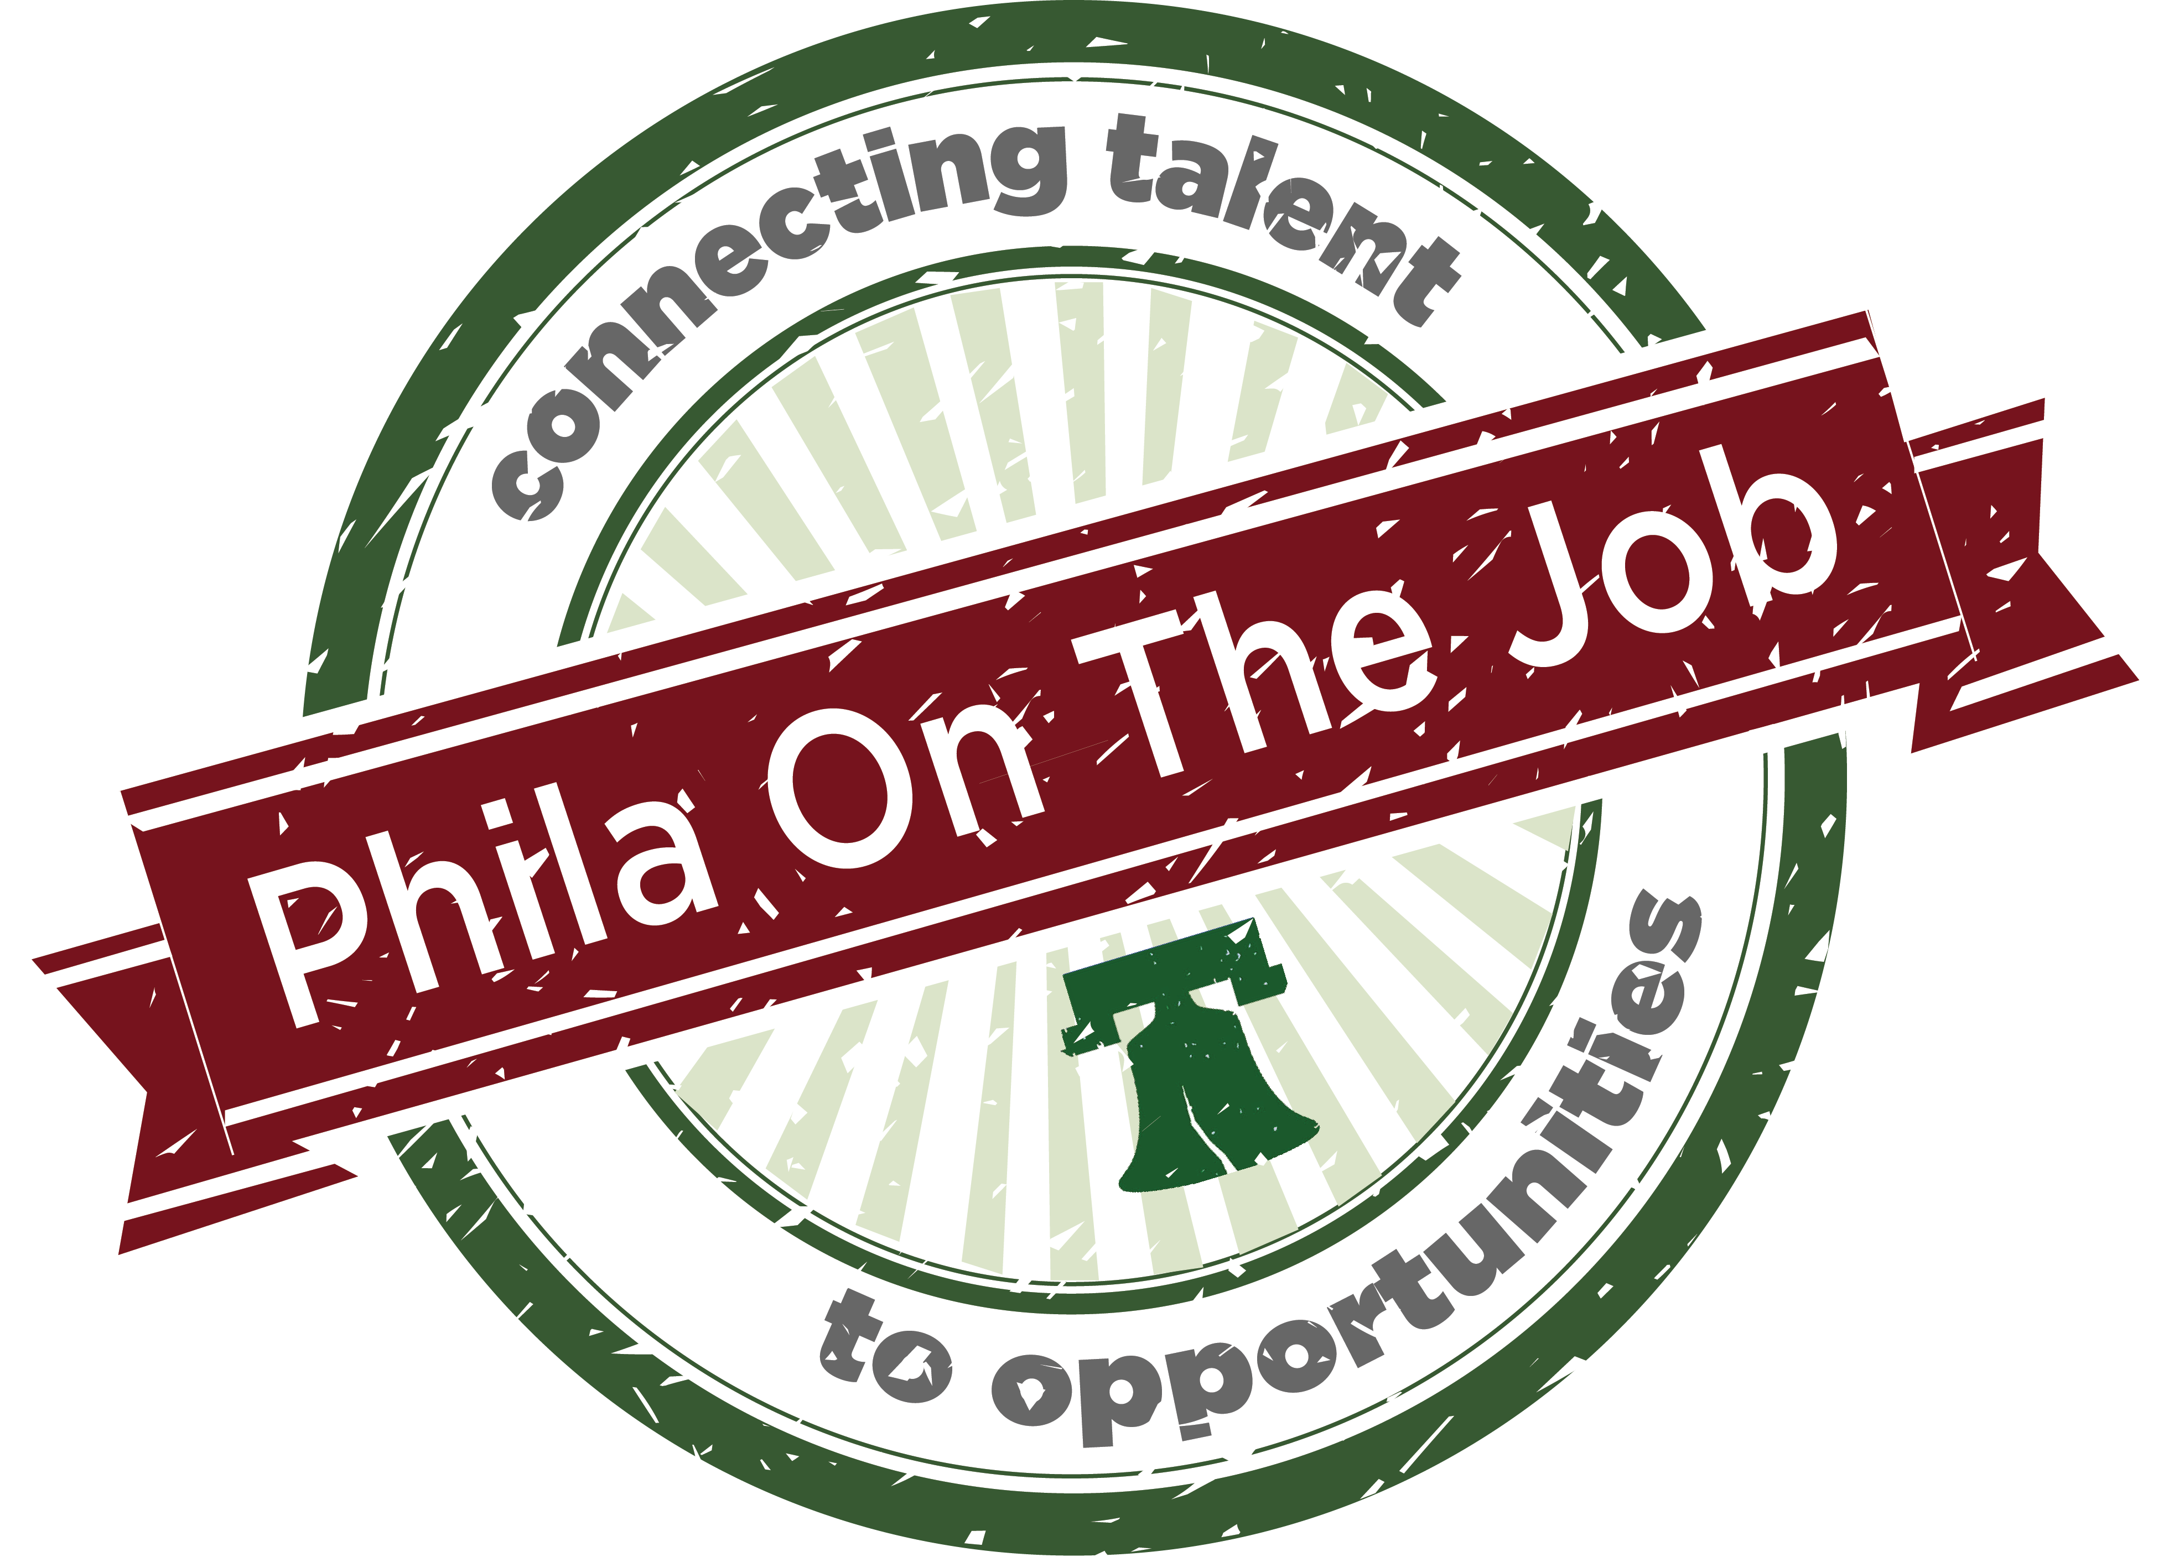

Philadelphia’s Employment First Stakeholder Event!
Agenda

- Welcome!

- Keynote by Julie Christensen, Executive Director, APSE
  - COVID-19: Impact on Employment of Individuals with Disabilities

- Wrapping Up Current Initiative
  - Report Out from Workgroups

- PhilaontheJob.org Website
  - Tools You Can Use!

- Phila on the Job Social Media
  - Get Connected!

- Moving Forward!
  - Engagement and Brainstorming in Breakout Rooms
  - Report Out

