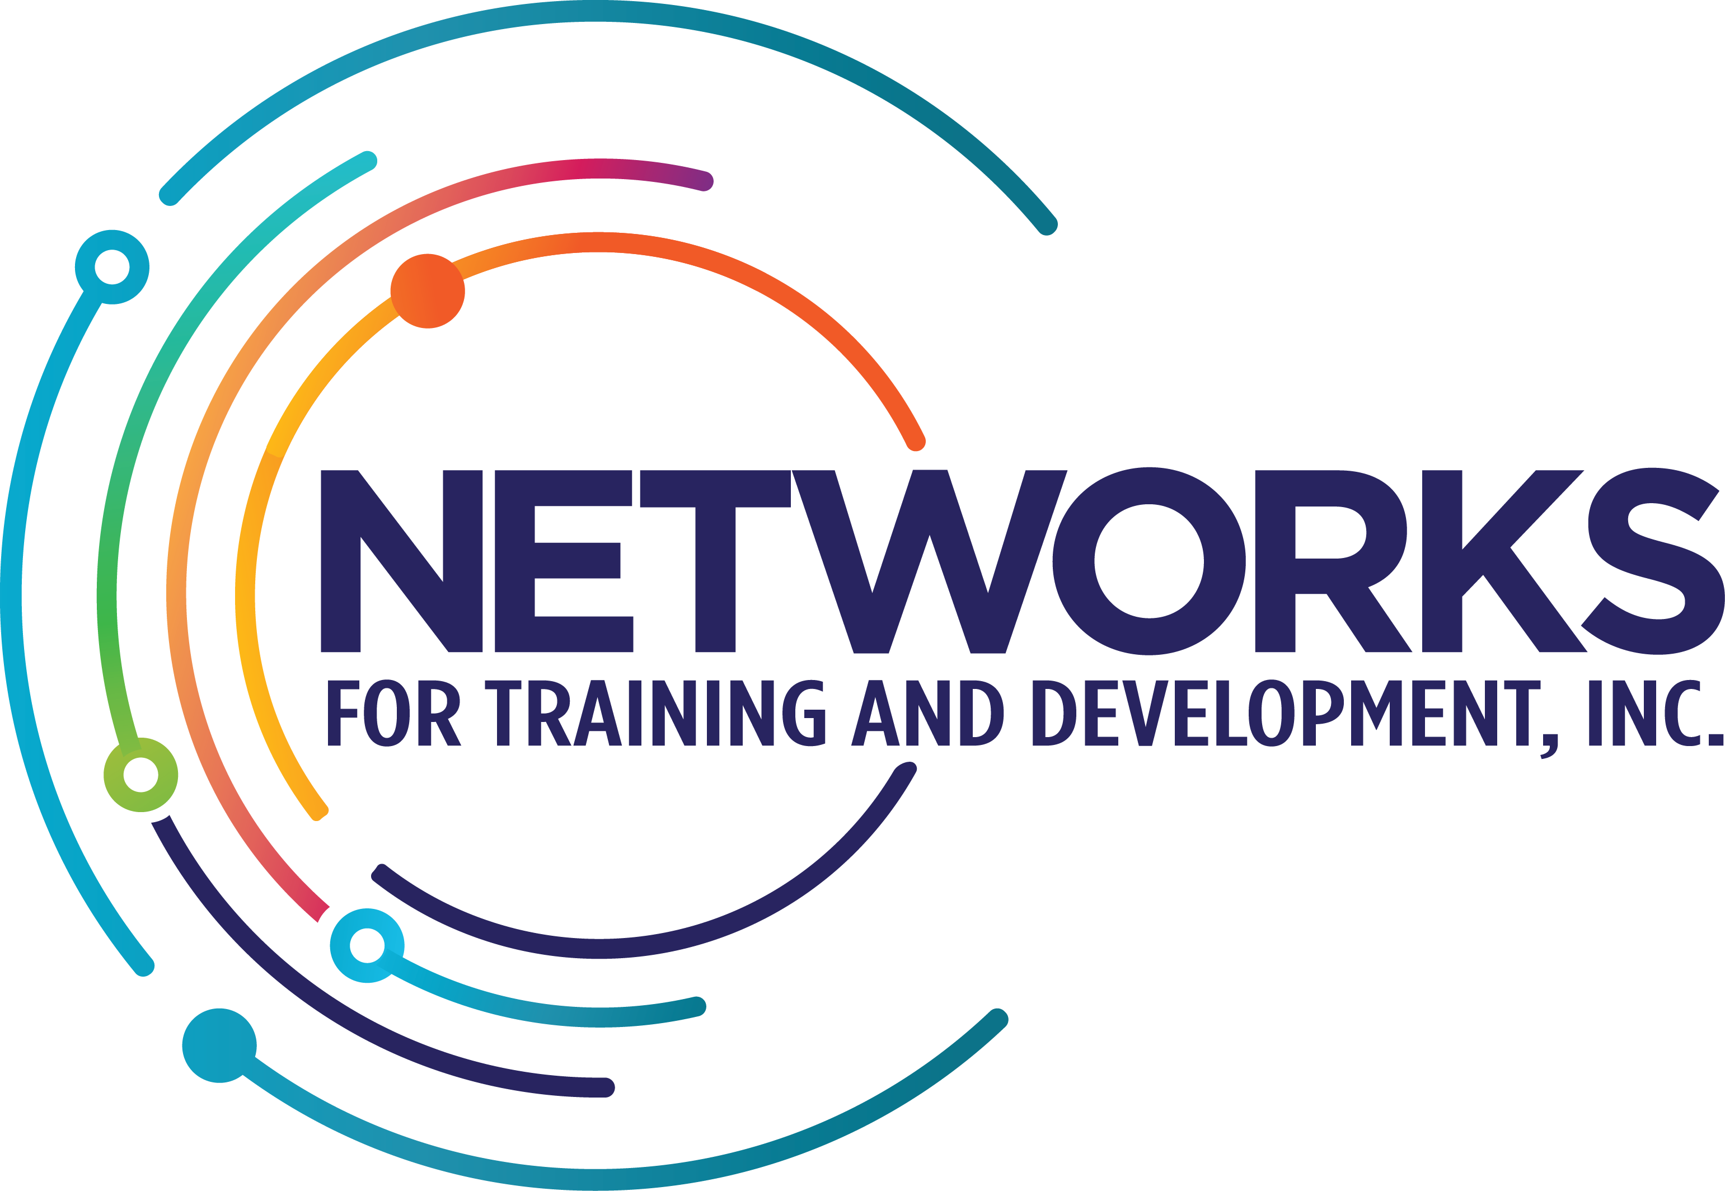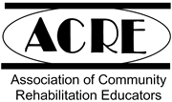
Networks for Training and Development, Inc.

Supported Employment 101

ACRE Certificate
Course Syllabus - Spring 2022 Virtual

Lead Coordinator: Joe Murphy joem@networksfortraining.org

Instructors:
Joe Murphy joem@networksfortraining.org
Bethany Friedl bethanyf@networksfortraining.org
Nikita Arnett nikitaa@networksfortraining.org
Tracy Lapreziosa tracyl@networksfortraining.org
Michelle Sparling michelles@networksfortraining.org

--------------------------------------------------------

Description & Purpose

The work of a job coach, employment specialist, or employment professional is so much more than “one job.” Many skills are necessary to do well and be successful. Job coaches need to be competent in all phases of the employment process, from the assessment or discovery phase to the fading and follow along the stage. Each requires diverse expertise and knowledge, with a hefty dose of people skills being of utmost importance. The most successful “employment professionals” connect well with people with disabilities, can assess an individual’s interests, desires, and skills, seek out the best possible job match, support the individual on the job and establish natural supports in such a way that the person can be successful on the job independently or with limited supports. These are only the primary roles of an employment professional. A variety of other “duties as assigned” are typically required for a person with a disability to become successfully employed. A great job coach can do it all.

Networks for Training and Development, Inc. has offered Supported Employment 101 (SE 101) in many formats for over 25 years. Given the increasing demands to do more with less, it has been difficult for employment professionals, who are so critical to success for people on the job, to attend training. Networks has developed a format for training in response to the increasing demands of an employment professional. Supported Employment 101 is now an ACRE-approved 40-hour course that takes place virtually. All information will be available through the Network’s app.

This course aims to give job coaches and other employment professionals with less than one year of experience the necessary tools and strategies to succeed in their role through hands-on fieldwork, homework and mentoring. For those providing employment support for a more extended period, this course can also be seen as a refresher and meets the mandatory Pennsylvania waiver certificate requirement (referencing the July 2017 waiver requirements of community-based staff acquiring either the CESP certification or the ACRE supported employment certificate). This course also meets the needs of Program Managers and Program Specialists who must meet the Pennsylvania State requirements.

Course Objectives
By participating in the ACRE Supported Employment 101 course, attendees will:
- Reflect on personal beliefs about persons with disabilities and employment
- Gain a solid foundation in an array of best practices in employment supports
- Learn about the numerous organizations and services that support the employment of people with disabilities from a local and national perspective
- Understand the importance of discovery and learn how to engage a team to gather relevant information to develop creative job development ideas
- Learn the basics of Social Security work incentives
- Compare and contrast various tools for assessing skills, abilities, and preferences
- Learn how to complete a situational assessment in a community business
- Gather and summarize relevant information about the results of the assessment process
- Identify and use basic strategies for job development
- Analyze the essential features of a job setting
- Learn how to educate employers on the value of hiring a person with a disability
- Acquire a working knowledge of the critical concepts of strategies used in customized employment
- Learn basic strategies in the development of self-employment and entrepreneurial ideas
- Develop and increase expertise in assistive technology and alternative augmentative communication on the job
- Reflect on the importance of balancing teaching and support on the job
- Become knowledgeable in the use of a systematic approach to teaching and support for success on the job
- Receive guidance from a mentor
- Build confidence and skills in your role as an employment professional
- Network with colleagues and form relationships for future collaboration

Required Materials

All participants MUST HAVE consistent internet access and their own work or personal email address. You will be required to answer knowledge checks post comments, questions, and thoughts to spur conversation.

We will explain how to access the network’s app during the precourse lesson. After our demonstration, please contact Diane Kehoe at dianek@networksfortraining.org or any course instructor if you have questions regarding the Network's app.

Course Assignments and Requirements

This certificate course will engage the learner through an in-depth and comprehensive study of the employment of people with disabilities as a whole. All attendees will be required to engage in the following areas:

Active Attendance - Active attendance is an integral part of this course to truly learn about the many topics involved in best practices in employment support. While this is self-paced, it is expected that students will complete modules in a timely fashion. New Modules will be introduced weekly. All six modules and assignments must be completed by the course end date. If a student needs an extension, it is expected the student will communicate this with the course leader.

There are six modules with additional lessons in each module. A new Module will be introduced each Sunday. Students will be required to complete all knowledge checks, discussion board posts, and assigned assignments attend at least two Network’s office hours, and complete a final project based on their discovery and career exploration profile to complete the course.

LESSONS - Each module comprises lessons that guide you through the basic principles for that subject area. Typically short video presentations (10 - 30 minutes in length). They may include links to podcasts, videos, or other content that you will be expected to view/listen to. Each lesson must be completed to progress to the next.

FIELDWORK ASSIGNMENTS – During lessons, you will be provided with tools to assist a person in successfully working. You will be required to use these tools with someone you support, demonstrating your mastery of this skill. Fieldwork assignments will appear as separate lessons in the module.

OFFICE HOURS MENTORING - Each participant will be required to attend two ritual mentoring sessions. Office hours will take place every Tuesday and Thursday from 1:00 to 2:00 p.m. EST. During these hours, participants can drop in and discuss any aspect of the course. Participants must choose at least two times, one before the end of week three and the second after week 4. Networks instructors will utilize these meetings to gauge whether the students have met the requirements for the skill-based competencies covered and advise the student on how to meet these if necessary. There will be a discussion of various tools during the class. Participants can attend any office hours offered by Networks. Office hours can be accessed through: https://networksfortraining.zoom.us/j/88434436640

KNOWLEDGE CHECKS – Knowledge checks of the materials presented will be required throughout the course. These need to be completed before proceeding to the next section. Students can review the materials presented if needed to answer any questions.

DISCUSSION BOARD - Although this offering of SE101 is virtual, we expect that all participants will actively engage with their instructors and classmates. Typically, attendees will have various questions, thoughts, interests, curiosities, and concerns regarding employment support. We encourage you to reflect upon your experiences, generate conversation regarding currently assigned readings or course material and respond to others' contributions via the provided discussion board. We also encourage you to explore and share any other information pertinent to this course.

DISCOVERY AND CAREER EXPLORATION FINAL PROJECT– All course attendees must complete the Discovery and Career Exploration Profile document with one individual they support or connect with periodically throughout the course. This comprehensive document provides detailed information about a person’s interests, strengths, experiences, and supports. Once this is completed, you will be asked to report your findings from the profile document to the instructors.

Supported Employment 101

Class Schedule

Class / Dates | Areas of Learning & Discussion
Module 1  Friday, April 1 | Getting Started:  The Foundations of Employment Supports  Presenter: Joe Murphy, Nikita Arnett, Bethany Friedl, Michelle Sparling, & Suzanne Erb  - Introduction to the course  - Review of syllabus  - Attitudes & beliefs about employment  - Basic SE principles  - Disability Etiquette  - Disability Disclosure  - EmploymentPolicy
Module 2  April 10th | The Discovery Process  Presenters: Joe Murphy & Nikita Arnett  - The role of discovery  - Explore the strengths, needs, and interests of individuals in the discovery process  - Discovery and customization  - Characteristics of an ideal job  - Exploration of community mapping  - The use of portfolios in the employment process  - Discussion of topics for the final Profile project  Work Incentives:  - Learn the differences between SSI and SSDI  - Learn about work incentives for each of the programs and how they will impact benefits  Learn how to provide support to prevent overpayment problems to the Social Security Administration
Module 3  April 17th | Job Development Part  Presenter: Bethany Friedl  - Deeper perspectives on engagement & strategic networking strategies  - Importance of Informational Interviewing  - Employer follow up  - Self-employment as a meaningful employment outcome  - Writing practical employment proposals and business plans  - Collaboration of services with funding entities
Module 4  April 24 | Teaching and Support & Systematic Instruction  Presenter: Joe Murphy  - Understand the methods and strategies for providing ongoing supports  - Learn to use task analysis  - Learn the importance of evaluating job performance  - Systematic instructional techniques  - Practicing systematic instruction  Review valuable tools for collecting data
Module 5  May 1 | Assistive Technology and Related Supports  Presenter: Tracey Lapreziosa  - What is Assistive Technology (AT)?  - Determining the best match for people  - Overview of low to high technology examples  Resources to tap into for next steps
Module 6  May 14 | Fading and Follow Along Supports  Presenters – Joe Murphy & Michelle Sparling  - Systematic approach to fading  - Fading and follow along with practices and resources
= 40 hours of instruction

