
The VARK Questionnaire – English Version (version 3)
How Do I Learn Best?
This questionnaire aims to find out something about your preferences for the way you work with information. You will have a preferred learning style and one part of that learning style is your preference for the intake and output of ideas and information.
Choose the answer which best explains your preference and circle the letter next to it. Please circle more than one if a single answer does not match your perception.
Leave blank any question which does not apply, but try to give an answer for at least 10 of the 13 questions.
When you have completed the questionnaire, find your score for each of the categories, Visual, Aural, Read/Write and Kinesthetic. Then, to calculate your preference, use the Scoring sheet.
- You are about to give directions to a person who is standing with you. She is staying in a hotel in town and wants to visit your house later. She has a rental car. I would:
- a. draw a map on paper
- b. tell her the directions
- c. write down the directions (without a map)
- d. collect her from the hotel in my car

2. You are not sure whether a word should be spelled 'dependent' or 'dependant'. I would:
- a. look it up in the dictionary
- b. see the word in my mind and choose by the way it looks
- c. sound it out in my mind
- d. write both versions down on paper and choose one

3. You have just received a copy of your itinerary for a world trip. This is of interest to a friend. I would:
- a. phone her immediately and tell her about it
- b. send her a copy of the printed itinerary
- c. show her on a map of the world
- d. share what I plan to do at each place I visit

4. You are going to cook something as a special treat for your family. I would:
- a. cook something familiar without the need for instructions
- b. thumb through the cookbook looking for ideas from the pictures
- c. refer to a specific cookbook where there is a good recipe

5. A group of tourists has been assigned to you to find out about wildlife reserves or parks. I would:
- a. drive them to a wildlife reserve or park
- b. show them slides and photographs
- c. give them pamphlets or a book on wildlife reserves or parks
- d. give them a talk on wildlife reserves or parks

6. You are about to purchase a new stereo. Other than price, what would most influence your decision?
- a. the salesperson telling you what you want to know
- b. reading the details about it
- c. playing with the controls and listening to it
- d. it looks really smart and fashionable

7. Recall a time in your life when you learned how to do something like playing a new board game. Try to avoid choosing a very physical skill, e.g. riding a bike. I learned best by:
- a. visual clues -- pictures, diagrams, charts
- b. written instructions.
- c. listening to somebody explaining it
- d. doing it or trying it

8. You have an eye problem. I would prefer the doctor to:
- a. tell me what is wrong
- b. show me a diagram of what is wrong
- c. use a model to show me what is wrong

9. You are about to learn to use a new program on a computer. I would:
- a. sit down at the keyboard and begin to experiment with the program's features
- b. read the manual which comes with the program
- c. telephone a friend and ask questions about it

10. You are staying in a hotel and have a rental car. You would like to visit friends whose address/location you do not know. I would like them to:
- a. draw me a map on paper
- b. tell me the directions
- c. write down the directions (without a map)
- d. collect me from the hotel in their car

11. Apart from the price, what would most influence your decision to buy a particular textbook?
- a. I have used a copy before
- b. a friend talking about it
- c. quickly reading parts of it
- d. the way it looks is appealing

12. A new movie has arrived in town. What would most influence your decision to go (or not go)?
- a. I heard a radio review about it
- b. I read a review about it
- c. I saw a preview of it

13. Do you prefer a lecturer or teacher who likes to use?
- a. a textbook, handouts, readings
- b. flow diagrams, charts, graphs
- c. field trips, labs, practical sessions
- d. discussion, guest speakers

The VARK Questionnaire – English Version Scoring Chart
Use the following scoring chart to find the VARK category that each of your answers corresponds to. Circle the letters that correspond to your answers.
e.g. If you answered b and c for question 3, circle R and V in the question 3 row.

Question | a category | b category | c category | d category
3 | A | R | V | K

Scoring Chart
Question | a category | b category | c category | d category
1 | V | A | R | K
2 | R | V | A | K
3 | A | R | V | K
4 | K | V | R
5 | K | V | R | A
6 | A | R | K | V
7 | V | R | A | K
8 | A | V | K
9 | K | R | A
10 | V | A | R | K
11 | K | A | R | V
12 | A | R | V
13 | R | V | K | A

Calculating your scores
Count the number of each of the VARK letters you have circled to get your score for each VARK category.

Total number of Vs circled =

Total number of As circled =

Total number of Rs circled =

Total number of Ks circled =

Scoring Instructions
Because respondents can choose more than one answer for each question the scoring is complex. It can be likened to a set of four stepping-stones across water.

- Add up your scores, V + A + R + K =
- Enter your scores from highest to lowest on the stones below, with their V, A, R, and K labels.
- Your stepping distance comes from this table.
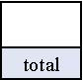
Total of my four VARK scores is | My stepping distance is
10-16 | 1
17-22 | 2
23-26 | 3
More than 26 | 4

- 3. Your first preference is your highest score so tick (check) the first stone as one of your preferences and enter its label on the stone.
- 4. If you can reach the next stone with a step equal to or less than your stepping distance then tick (check) that one too.

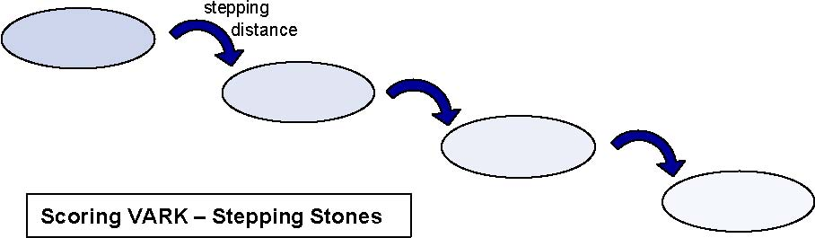
Once you cannot reach the next stone you have finished defining your set of preferences. If you have more than one preference checked you should read the material on multimodal preferences. If you have checked only the first stone go to the help sheet for that single preference.

For those with a Single Preference:
If you have a single preference (V, A, R or K) you may want to find out if your preference is mild or strong or very strong. You can use the table below to find out.

You will need to use your total number of your responses (from step 1 above). This is used for finding your place in Column One. Place a ruler on your line in Column One.
Now you will need to know the difference between your highest score and your next highest score. Read across your line until you reach the column that shows the difference between your highest and your next highest scores.

Result
