The Learning Style Challenge
As we have learned, none of us rely on only one learning style. Most of us use a mix of these styles when we learn, or are multi-modal… but we certainly do have our learning preferences. Therefore it is important that we use a variety of styles in our teaching to take advantage of a person's multimodal intelligences. This stepping stone graphic from the VARK assessment is really helpful in demonstrating the preferences we have in how we learn.
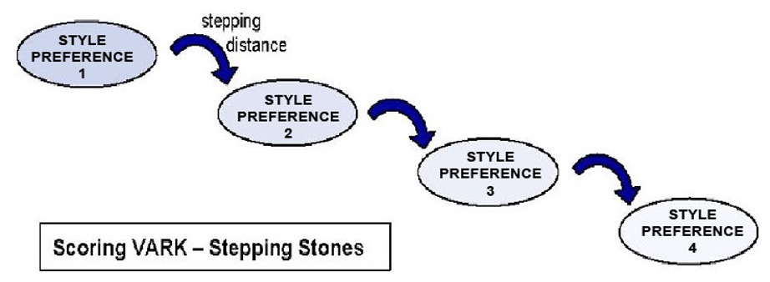
Learning styles not only affect how we “receive” information, they can also impact how we demonstrate mastery / execute the things we learn. The following exercise is designed to help us think not only of what our preferred styles are, but also how they blend together to create wonderfully rich experiences.


The Scenario:
You are the owner of a cooking school, and your four new budding chefs have arrived. They all are excited about learning to cook, but each have distinct ideas about how that should occur. You are struggling to figure out the best way to teach this group of new chefs all they need to know.

The Players:
Vince. Vince wants to see pictures of every step of the recipe he is being asked to make. He likes to study the photos, so he understands each step in the sequence of his recipe. He wants a map of the kitchen so he knows where everything is he might need.
Rebecca. Rebecca has already started reading through the recipes, writing down any areas of concern / interest, and breaking down any complex steps. She wants a list of how-to’s for each piece of equipment. Rebecca likes to understand the various cooking procedures she will be using, and the function of all the equipment in the kitchen, and prefers manuals she can refer back to.
Kenny. Kenny really wants to jump into learning to cook. He wants the opportunity to watch an experienced chef cook a recipe, then try it himself. He loves watching cooking shows on YouTube, cooking the recipe along while he watches. Kenny wants to see videos or watch an experienced person on how to use some of the equipment he will need to use. He would LOVE to own a video cookbook that he can watch and try.
Adam. Adam wants to discuss each recipe he is assigned (or at least listen to a recording of the directions). He wants an opportunity to ask questions about any steps he is concerned about. He thinks there should be an orientation to the kitchen so he knows where things are and how to use them.

The Challenge:
Using what you have learned about learning styles, address the following concerns:
- identify what you believe to be the learning style / preference of each of our budding chefs (visual, auditory, reading, or kinetic / touch).
- Suggest a means for the accommodating their multiple intelligences while they learn how to cook.
- Discuss how you might focus your own teaching and curricula to accommodate different learning preferences. Provide specific examples of how this might be done in the course you are creating, and in the other trainings you will be conducting / managing.
- Share your results and conclusions with your instructor via the UPLOAD button below.
[We encourage you to remember that most of us DO NOT use only one learning style / preference. We use of mix of these styles, but our preferences do show.]

"The more people involved in an activity,
the richer the experience – the more learning
styles you address in your teaching,
the richer the learning experience."

